**ST.THERESA’S ARTS AND SCIENCE COLLEGE FOR WOMEN,**

**THARANGAMBADI - 609313**

**DEPARTMENT OF PHYSICS**

Analyzing the Performance & Efficiency of The Radisson Hotels using Data Visualization Techniques

BY

TEAM LEADER

**R.DEEBIKA**

TEAM MEMBERS

**M.ABILARA**

**D.RAMYA**

**M.DHARSHINI**

### **Analyzing the Performance & Efficiency of the Radisson Hotels Using Data Visualization Techniques**

**Introduction:**

**Overview:**

The purpose of the project is to visualize the readers about the utilization of service design methods for the innovation and development of the communication system in a profit and service oriented business. The project is written with an aim of improvement in the existing communication process in an innovative way for the chosen Case Company “Radisson Hotels”. Customer satisfaction with increased value in their services will be our end-result. Moreover, the knowledge gained during our studies are applied in this research and concluded up with development proposal.

Two students will be responsible for the co-ordination to complete this project. The observation is done closely with two different perspectives with the help of Radisson Hotel members. While one perspective is prepared from external point of view, the other observa-tion is done from a staff’s viewpoint too as one of us has already been an intern for the case company.

The concept of offering hospitality services can be dated back to the evolution of human civilization. The development of the civilization has also led to the change in the industry. The continuous development has created opportunities for the entrepreneurs to compete against each other and improve their existing services. As services are intangible, there is always space for the development of services from the customer’s point of view in this sector. Radisson Blu already have their set standards of quality services offering to its customers. But, as the customers tend to keep their expectations high every day, the company has to maintain their quality of service each day focusing on the changing trends in order to keep growing.

Communication is one of the most crucial factors in organizations. Communication exists in many levels. Messages are communicated by words, body language, acts and values. Communication in the hospitality industry is challenged especially by cultural and language barriers. This is an important factor that must be taken into account when closing communication gaps within the hospitality industry. Communication is different between customer and employees, and managers must be able to understand these differences. Messages are delivered through many channels in the 21st century. One significant change is the common use of technology and access to the World Wide Web. Technology is so common, that mangers must understand how communication is evolving within the world of technology. For example, people access more internets through their smart phone and mobile applications rather than from the standard desktop computer or PC. The evolution in communication affects organizational communication in marketing, Public Relation and almost every aspect of their day-to-day activities.

**Purpose:**

The purpose of this project is to develop the current communication process of ordering catering service in room at the case company Radisson Hotels by the use of service design tools. The importance of communication should not be ignored or underrated as it directly affects the experience of employees and the end user. The research was carried out by two students, where one had experience of internal communication in the organization through work as an intern and the other had been able to observe the room service process externally, as a customer. Due to this combination of internal and external observations, a new service product was innovated as an application. The result of this research will make the communication flow better and assist the core business of the organization.

The theoretical framework of this report explains about the understanding of communication, its components and channels. In addition, this chapter also reviews the communication in the organizations, reasons for communication gap and the significant role of digital media that affect the buying behavior of consumers. It also explains the flow of communication within the organization.

The project was conducted by using the tools of service design. The service design approach offers the users a wide range of research methods in different phases. According to the need of the project, methods such as contextual interview, persona, brainstorming and service design were selected. Service design tools are effective in creating innovative solutions in the service field.

The implementation of this project in the case company will reduce the workload of employees in the reception and restaurant department of the hotel with the help of application that we have innovated during the project, the kitchen chef will receive the food orders directly from the customers. At the same time, the customers will also get real-time information about their orders. This research will help in reducing the touch points like reception and restaurant department in the room service process and make the service smooth and fast.

**Problem Definition and Design Thinking**:

The current communication process of ordering the food by customers contains unnecessary touch-points in the hotel. The main problem due to the current ordering system is hampering the reception department. It is increasing work load for the employees of reception department as handling food orders becomes an additional task for them.

Moreover, sometimes receptionist forgot to ask additional information regarding preparation of food. It may affects the customer satisfaction level as they might not received the desired meal for an example Receptionist sometime forgot to write the degree of tenderness of food such as medium cooked or well done. Chef also gets confused because of lack of exact information.

We found out customer can order through phone by one touch service to reception. But receptionist has to inform kitchen manually about the order. It makes the process slow in busy hours and increases the work load. More over we have observed during internship that language and accent sometimes makes difficult for customer to order. This accent and language problem misleads the customer to order and takes lot of receptionists’ time to explain. Selection of media plays vital role in customer satisfaction in this digital world as described in the literature review.

**Empathy Map:**

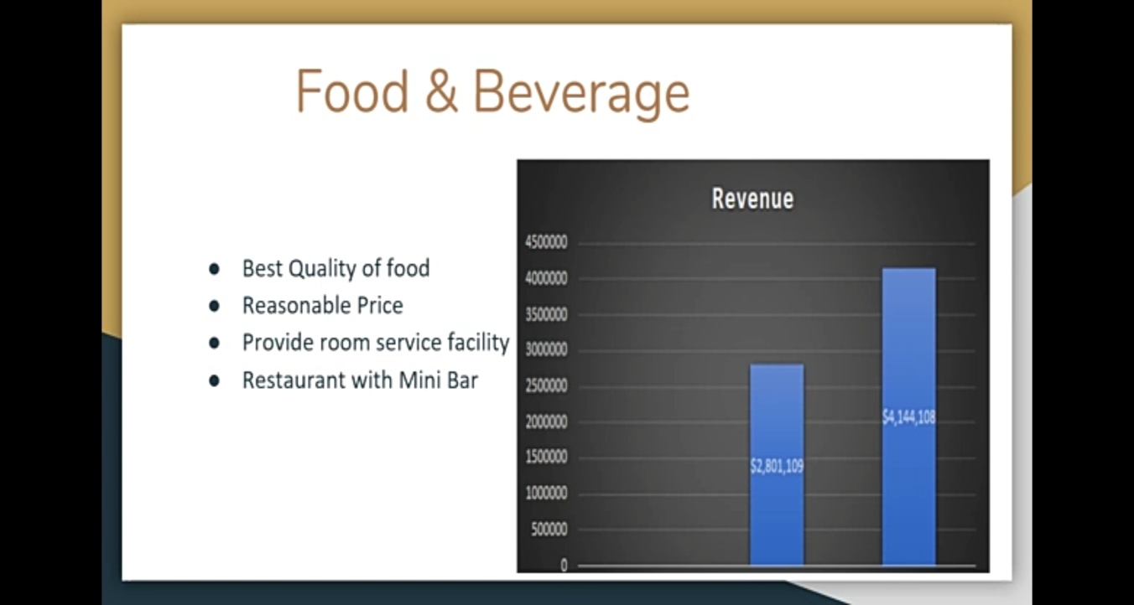

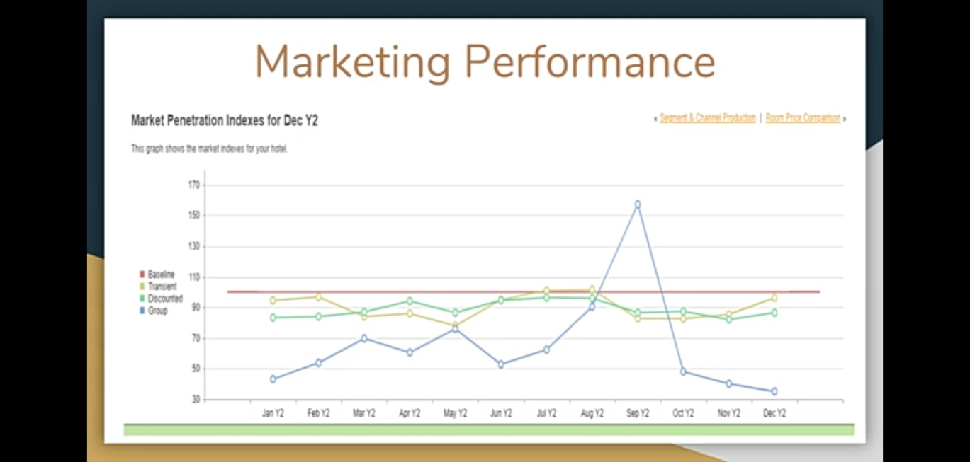

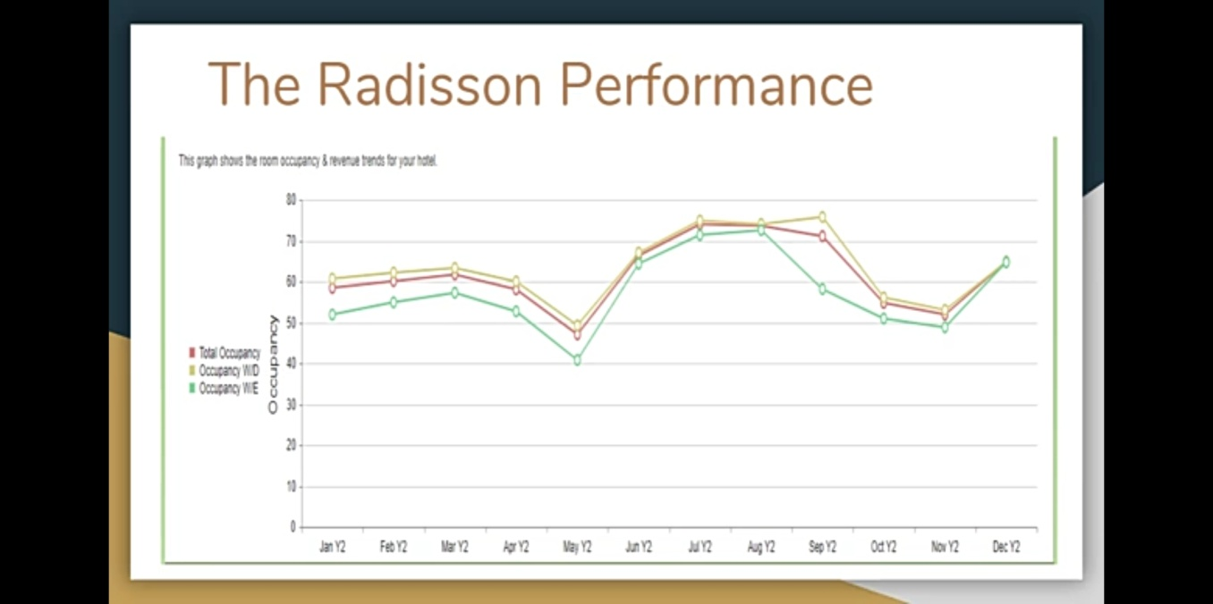

**Location for Radisson Hotels in the World**

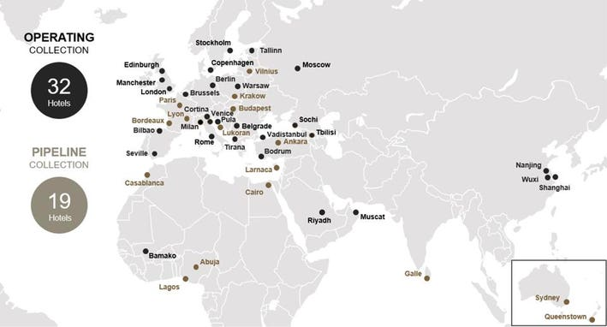

**Ideation and Brainstorming Map:**

Brainstorming is used to generate alternative solutions and opportunities quickly. They identify the most interesting and important ideas to take forward as part of the design process. It is particularly useful to break out of established patterns of thinking, and develop new ways of looking things. It also helps to overcome many of the issues. Aims of this method are generate a large number of potential ideas, identify key ideas to develop further and create a shared understanding of potential opportunities around a topic or theme.

As the name suggests, brainstorming is an effective technique to create more ideas in a short time. The brain is forced to exercise quickly to generate solutions alternatively. The purpose of using the method is only to generate a lot of possible ideas from other people or group.

Brainstorming comes as a convenient tool for student researching. It is easy to use the method in the classroom with other classmates. Smaller groups can be created to discuss and share the ideas on a given topic or problem. As individuals have the potential of thinking differently than each other, this ensures that the groups will come out with different pattern of ideas and thoughts. Brainstorming is also a common method for the students to use to get different kind of ideas from other skillful minds.

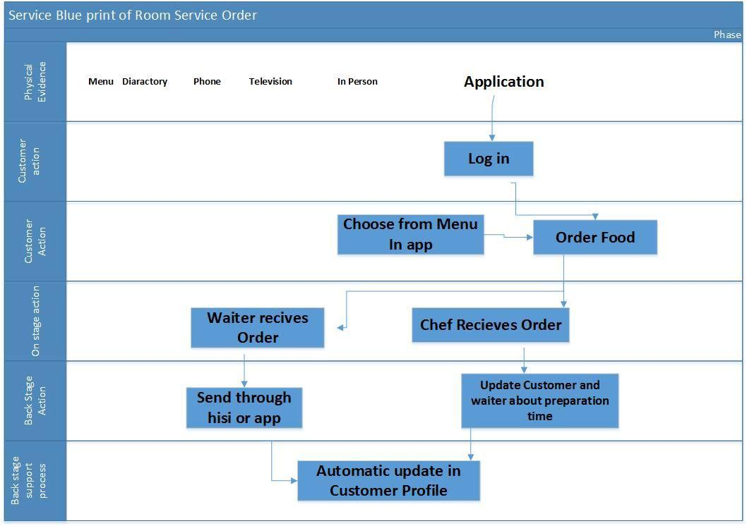**Service blueprint after proposed solution**

**Research and Results**

This chapter of thesis will provide an overview of our research process and findings. It also discusses the present situation of Radisson Hotel communication process for ordering food by in-room customers. Some of the qualitative service design tools such as interviews, persona, brain-storming and blueprinting are used to conclude results. Furthermore, a proposal is recommended based on the research process.

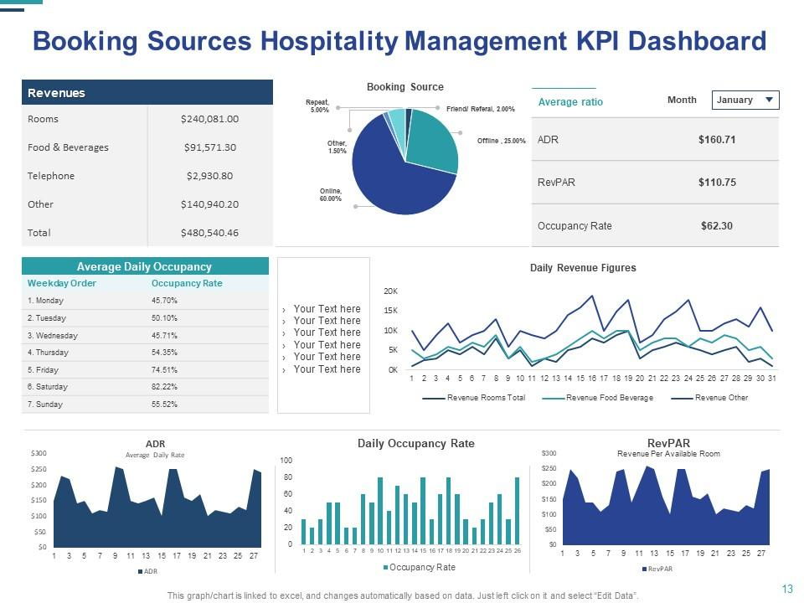

**Advantages:**

Employees at Radisson Hotels rank their Perks and Benefits lower than most, ranking them in the Bottom 10% of all similar sized companies with 501-1,000 Employees on Comparably.

The Operations department and African American/Black employees at Radisson Hotels rank their Perks and Benefits the highest, while Caucasian employees and employees with Over 10 Years experience rank the Perks and Benefits at Radisson Hotels the lowest against other demographic groups at the company.

Strengths are defined as what each business does best in its gamut of operations which can give it an upper hand over its competitors. The following are the strengths of Radisson Hotels:

* **Service:**As the tagline of Radisson indicates, the service motto of the hotel chain is “Yes I Can.” The employees are trained to never say no or show disapproval for customer requests, always positive pleasant and willing to serve. This ensures that their service is top grade and consistent across their properties in various parts of the world.

**Wide network:**The Radisson Group has the presence in almost 73 countries across the world and has around 1000 properties. Though the majority of their hotels are in the United States where they have a wide network.

**Service:**Shangri-La Hotels & Resorts are famous for the top service quality and customers are given a lot of personal attention. The decor of the restaurant is imperial and the architecture inspirational and the service quality is consistent across all its properties.

* **Radisson Rewards:** Radisson is popular for their rewards program which has often been considered as an industry benchmark. Their rewards scheme consists of member rates which are lower than the standard room rates for regular customers. Personalized service options, discounts on food and drink and free award nights. The points can be collected for stay across any Radisson Hotel and can be redeemed in any of their hotels as well.
* **Wide target segments:**The hotel chain owns prestigious hospitality brands like Radisson, Radisson Blu, Radisson Red, Country Inns and Suites by Radisson and Park Inn by Radisson. While Radisson Blu refers to hotels outside the United States which cater to luxury travelers, Radisson Red is for young customers while Park Inn is for economy segment. Thus the hotel chain has something for all income customers which in turn help them target larger audiences.
* **High brand recall:**Radisson is a group of hotels with a unique brand identity which is synonymous with high-end service quality. Through their every moment matters tagline, which also reflects their service philosophy, the group has been able to emotionally connect with their customers.

**Disadvantages:**

Weaknesses are used to refer to areas where the business or the brand needs improvement.   Some of the key weaknesses of Radisson Hotels are:

* **Expansion plans:**Radisson Group is planning to expand further into the Asia Pacific and this will also be backed by a restructuring and leadership change. This change will come with a lot of expenses and, may prove to be costly for the company. The restructuring and leadership change may also mandate the need for a change of culture which may be challenging.
* **High promotions costs:** The Radisson Group is planning to reposition and rebrand itself for which the budget assigned is 200 million USD. At an age where the hotel business is facing cost management challenges, it may not be the right move.
* **Too much spread:**Radisson Group has under its portfolio eight different hotel brands across eight segments and operations in more than 73 countries across various continents. This huge spread is creating a disconnect between the hotel categories and sub-brands. This is also confusing the customer who expects the same service quality in all Radisson hotels and does not realize that it may vary depending on which segment the sub-brand caters to.

**Application:**

Without the problems, no new creativity will occur. It means that to create new innovations and development, problems and obstacles are the best guides. The important thing to note is the solutions and approach to the problems. Without the suitable approach, the path will create even much trouble for the existing problem.

Without losing the focus, one needs to create their own path that will lead them to their goals. In this project report, the main goal was to create sustainable and innovative solutions to the problems which were recognized. As the realized problems are discussed in the chapter above, applicable solutions were the main target of this whole research.

As mentioned above in the Digital consumer literature review Customers are turning towards the digital world, we have come up with the innovation of an “Application”. Based on the above findings it has been noticed that touch points can be reduced by using the new application Technology. In which customers can order directly to chef by choosing the menu in application or in their browser. Chef can then accept the order by just clicking accept on tablet placed in the kitchen. Chef can also tell customer about the estimated time of delivery. This way chef can see the situation of the orders and can tell the exact estimated time. Consumers prefer real time information and this can be achieved by just implementing this new feature. Application can also allow customer to pay from card or to attach the bill with, that can be paid later during checking out. As in now they have to walk all the way down to reception if they want to pay on the spot.

Medium plays a vital role in sending and receiving the information as mentioned in the Components of communication. It is important for Encoder and decoder to understand the exact context of communication. Language is a big barrier between both the entities while communication in multicultural environment and as Radisson Hotel is a Multinational company lot of customers also stay their who cannot read or write English.

Pictures are the most helpful tool to assist in these condition. This application will also assist customer to order by selecting the pictures. More over consumer will be more comfortable in ordering the food by just selecting them instead of explaining it on phone or by travelling all the way to restaurant.

The application will reduce the touch points like reception and restaurant department. Orders will go directly to chef and will be updated automatically hence it will reduce load from restaurant and reception department. More over the consumer can comment and will choose all the options, it will not create confusion for chef and his team. Due to all above mentioned factors application will reduce the time of room service (catering services).To ensure prompt response from hotel management staff, applicants should ensure all information provided on hiring materials remains accurate and up-to-date. Job seekers should keep in mind hiring managers may necessitate patience during the hiring process depending on multiple factors, including the number of applicants for similar positions, administrative responsibilities, and guest needs. Application follow-ups should take place over the phone or in person and should not interrupt peak check in and check out times. Ask hiring managers what the best time to inquire without hiring decisions and try to limit follow-ups to no more than once a week.

**Conclusion**

In conclusion, service design tools are effective in creating innovative solutions in the service field. The tools guided us in every step of our thesis research process and gave us idea on creating a new innovational idea for the case company. As we were familiar with the use of design methods from our previous studies, we had chosen appropriate methods that supported our thesis process. The service design tools are so effective that the result of one tool pro-vides assistance to another up-coming tool which leads the user to reach its final goals. The results achieved after the use of methods will promote better service to customers, save time and reduce work load for the employees.

**Future scope:**

With a variety of positions available in the hospitality industry, Radisson seeks to fill jobs such as front desk attendants, housekeepers, door attendants, concierge, and other various restaurant roles and maintenance positions. Entry-level worker must only meet general hiring requirements, such as standing at least 18 years of age and in possession of high school diplomas. Previous experience remains beneficial but not specifically required for most entry-level positions. Applicants should exhibit team-oriented attitudes, flexible scheduling options, and excellent customer-service skills.

Career-minded individuals, especially ones with decisive natures, innate leadership skills, and desires to work in the hospitality industry, should seek to join the Radisson management team. The hotel chain offers numerous opportunities as supervisors, as employees newer to the management field may work as department supervisors, such as front desk supervisor, housekeeping supervisor, or food and beverage leader. More experienced supervisory candidates may fill assistant hotel manager and general manager roles with the franchised hotel chain. Unlike most entry-level positions, managers must possess previous experience working in the hospitality industry and typically should possess at least a two-year degree in a related field.

First built in Minneapolis, MN, and later made a subsidiary of the Carlson group, Radisson Hotels now enjoys over 400 locations around the world. Applicants interested in entry-level hospitality positions should visit the company website or by turning in paper applications at a hotel location. Professionals with hotel management experience should consider supervisory openings.